Name: Aman Kumar Singh

Enrollment No: 200510101159

Batch: C

INTERNAL - 03

**Q.1) Create table employee(empID,emp_name,salary,dept)**

**Solution: -**

|  |
| --- |
| **use internal;**  **CREATE TABLE employee(**  **empID INTEGER(5),**  **emp_name VARCHAR(25),**  **salary DECIMAL(10,2),**  **dept VARCHAR(15)**  **);** |

**Output: -**

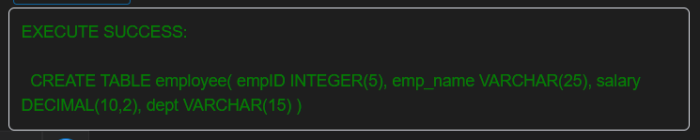

**Q.2) Insert 5 rows in employee table.**

**Solution: -**

|  |
| --- |
| **INSERT INTO employee**  **(empID, emp_name, salary, dept)**  **VALUES**  **(159, 'Aman Kumar Singh', '25000', 'Software'),**  **(131, 'Yash Raj', '21000', 'Technical'),**  **(167, 'Varunkumar Singh', '30000', 'Gamer'),**  **(161, 'Digpal Singh', '35000', 'Services'),**  **(171, 'Kartik Sonkusre', '35000', 'Banking');**  **SELECT * FROM employee;** |

**Output: -**

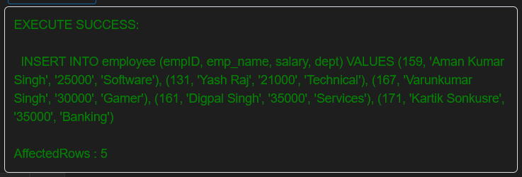

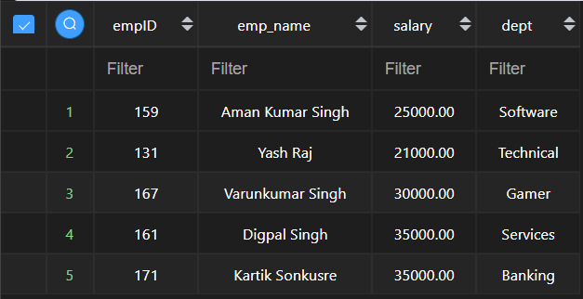

**Q.3) Write PL/SQL block to demonstrate use of implicit cursor.**

**Solution: -**

|  |
| --- |
| **create table friends**  **( Name varchar(20),**  **Eno number(5),**  **City varchar(10)**  **);**  **Insert Into friends**  **(Name, Eno, City)**  **Values**  **('Aman Kumar Singh', 159, 'Vaishali'),**  **('Yash Raj', 131, 'Hajipur'),**  **('Varun Kumar Singh', 167, 'Mumbai'),**  **('Digpal Singh', 161, 'Delhi');**  **DECLARE**  **total_rows number(4);**  **BEGIN**  **UPDATE friends SET Eno=Eno+10;**  **IF SQL%NOTFOUND THEN**  **dbms_output.put_line('there is no friends selected');**  **ELSIF SQL%FOUND THEN**  **total_rows :=sql%ROWCOUNT;**  **dbms_output.put_line(total_rows ||'friends selected');**  **END IF;**  **END;**  **SELECT * FROM friends;** |

**Output: -**

